Active Cases -

By removing **deaths** and **recoveries** from **total cases,** we get "currently infected cases" or "active cases" (cases still waiting for an outcome).

### Growth Factor of Monthly Confirmed Cases

Growth factor is the factor by which a quantity multiplies itself over time. The formula used is **month Confirmed Cases** / **Confirmed Cases on the previous month**.

A growth factor **above 1 indicates an increase**, whereas one which remains **between 0 and 1 it is a sign of decline**, with the quantity eventually becoming zero, whereas a growth factor constantly above 1 could signal exponential growth

### Total Cases (worldwide)

"Total Cases" = total cumulative count (927,980). This figure therefore includes deaths and recovered or discharged patients (cases with an outcome).

Types

**CREATE** **TYPE** countries_t **AS** **OBJECT** **(**

countryid int**,**

country_Region varchar2**(**60**),**

province_State varchar2**(**50**),**

latitude number**(**8**,**4**),**

longtude number**(**8**,**4**)**

**)**

**/**

**create** **TYPE** panademic_info_t **as** **object(**

cid **ref** countries_t**,**

pdate date**,**

no_of_covid_confirmed number**(**5**),**

no_of_covid_Recovered number**(**5**),**

no_of_covid_deaths number**(**5**)**

**)**

**/**

-tables-

**create** **table** countries_tlb **of** countries_t**(**

countryid **primary** **key**

**)**

**/**

**create** **table** panademic_info **of** panademic_info_t

**/**

------------- for testing-------------------

**insert** **into** countries_tlb **values(**countries_t**(**1**,**'British'**,**'uk'**,**123.123**,**321.123**))**

**/**

conn **/** **as** sysdba

**CREATE** **OR** **REPLACE** DIRECTORY MY_DIRECTORY **AS** 'c:\dsda_it17167710_mid\';

**GRANT READ,** WRITE ON DIRECTORY MY_DIRECTORY TO janith_dsds;

**GRANT EXECUTE** ON SYS.utl_file TO janith_dsds;

**conn** janith_dsds/dsda

**DECLARE**

F UTL_FILE**.**FILE_TYPE**;**

WRITE_FILE UTL_FILE**.**FILE_TYPE**;**

covid_LINE VARCHAR2 **(**1000**);**

covid_date VARCHAR2**(**50**);**

i number**(**5**);**

**BEGIN**

F **:=** UTL_FILE**.**FOPEN**(**'MY_DIRECTORY'**,**'c:\dsda_mid_it17167710\covid_Confirmed.CSV'**,**'R'**);**

WRITE_FILE **:=**UTL_FILE**.**FOPEN**(**'MY_DIRECTORY'**,**'c:\dsda_mid_it17167710\covid_dates.CSV'**,**'W'**);**

**IF** UTL_FILE**.**IS_OPEN**(**F**)** **THEN**

**LOOP**

**BEGIN**

UTL_FILE**.**GET_LINE**(**F**,** covid_LINE**,** 1000**);**

**IF** covid_LINE **IS** **NULL** **THEN**

**EXIT;**

**END** **IF;**

i **:=**5**;**

**LOOP**

**BEGIN**

covid_date **:=** **replace(**REGEXP_SUBSTR**(**covid_LINE**,** '("([^"]*)")|[^,]+'**,** 1**,** i**),**'"'**,**''**);**

UTL_FILE**.**PUT_LINE**(**WRITE_FILE**,**covid_date**);**

**COMMIT;**

i**:=**i+1**;**

**IF** covid_date **IS** **NULL** **THEN**

**EXIT;**

**END** **IF;**

**END;**

**END** **LOOP;**

**EXIT;**

**create** **SEQUENCE** seq1

**start** **with** 1

**increment** **by** 1**;**

**CREATE** **OR** **REPLACE** **TRIGGER** covid_countries_trigger

**BEFORE** **INSERT**

**ON** countries_tlb

**REFERENCING** **NEW** **AS** **NEW**

**FOR** **EACH** **ROW**

**BEGIN**

**SELECT** seq1**.nextval** **INTO** **:NEW.**countryid **FROM** dual**;**

**END;**

**/**

-----------------------------------------------------

**ALTER** **SESSION** **SET** NLS_DATE_FORMAT **=** 'MM/DD/YYYY'**;**

**DECLARE**

ConfirmedCSV UTL_FILE**.**FILE_TYPE**;**

DeathsCSV UTL_FILE**.**FILE_TYPE**;**

RecoveredCSV UTL_FILE**.**FILE_TYPE**;**

WIRTE_FILE UTL_FILE**.**FILE_TYPE**;**

covid_LINE_C VARCHAR2 **(**2000**);**

covid_LINE_D VARCHAR2 **(**2000**);**

covid_LINE_R VARCHAR2 **(**2000**);**

covid_LINE2 VARCHAR2 **(**2000**);**

covid_date VARCHAR2**(**50**);**

covid_Confirmed NUMBER**(**7**);**

covid_Deaths NUMBER**(**7**);**

covid_Recoverd NUMBER**(**7**);**

covid_state VARCHAR2**(**50**);**

covid_region VARCHAR2**(**50**);**

covid_lat NUMBER**(**8**,**4**);**

covid_long NUMBER**(**8**,**4**);**

i number**(**5**);**

**row** number**(**5**);**

**BEGIN**

ConfirmedCSV **:=** UTL_FILE**.**FOPEN **(**'MY_DIRECTORY'**,** 'c:\dsda_mid_it17167710\covid_Confirmed.CSV'**,** 'R'**);**

DeathsCSV **:=** UTL_FILE**.**FOPEN **(**'MY_DIRECTORY'**,** 'c:\dsda_mid_it17167710\covid_Deaths.CSV'**,** 'R'**);**

RecoveredCSV **:=** UTL_FILE**.**FOPEN **(**'MY_DIRECTORY'**,** 'c:\dsda_mid_it17167710\covid_Recovered.CSV'**,** 'R'**);**

i**:=**0**;**

**row:=**0**;**

**IF** UTL_FILE**.**IS_OPEN**(**ConfirmedCSV**)** **AND** UTL_FILE**.**IS_OPEN**(**DeathsCSV**)** **AND** UTL_FILE**.**IS_OPEN**(**RecoveredCSV**)** **THEN**

**LOOP**

**BEGIN**

i**:=**i+1**;**

UTL_FILE**.**GET_LINE**(**ConfirmedCSV**,** covid_LINE_C**,** 2000**);**

UTL_FILE**.**GET_LINE**(**DeathsCSV**,** covid_LINE_D**,** 2000**);**

UTL_FILE**.**GET_LINE**(**RecoveredCSV**,** covid_LINE_R**,** 2000**);**

**IF** i **=**1 **THEN**

**CONTINUE;**

**END** **IF;**

**IF** covid_LINE_C **IS** **NULL** **THEN**

**EXIT;**

**END** **IF;**

i **:=**5**;**

covid_state **:=** **replace(**REGEXP_SUBSTR**(**covid_LINE_C**,** '("([^"]*)")|[^,]+'**,** 1**,** 1**),**'"'**,**''**);**

covid_region **:=** REGEXP_SUBSTR**(**covid_LINE_C**,** '("([^"]*)")|[^,]+'**,** 1**,** 2**);**

covid_lat **:=** REGEXP_SUBSTR**(**covid_LINE_C**,** '("([^"]*)")|[^,]+'**,** 1**,** 3**);**

covid_long **:=** REGEXP_SUBSTR**(**covid_LINE_C**,** '("([^"]*)")|[^,]+'**,** 1**,** 4**);**

**INSERT** **INTO** countries_tlb **VALUES(**0**,**covid_region**,**covid_state**,**covid_lat**,**covid_long**);**

**COMMIT;**

**row** **:=row**+1**;**

WIRTE_FILE **:=** UTL_FILE**.**FOPEN **(**'MY_DIRECTORY'**,**'c:\dsda_mid_it17167710\covid_dates.CSV'**,** 'R'**,**2000**);**

**IF** UTL_FILE**.**IS_OPEN**(**WIRTE_FILE**)** **THEN**

**LOOP**

**BEGIN**

UTL_FILE**.**GET_LINE**(**WIRTE_FILE**,** covid_LINE2**,** 100**);**

**IF** covid_LINE2 **IS** **NULL** **THEN**

UTL_FILE**.**FCLOSE**(**WIRTE_FILE**);**

**EXIT;**

**END** **IF;**

covid_date **:=** REGEXP_SUBSTR**(**covid_LINE2**,** '("([^"]*)")|[^,]+'**,** 1**,** 1**);**

covid_Confirmed **:=** REGEXP_SUBSTR**(**covid_LINE_C**,** '("([^"]*)")|[^,]+'**,** 1**,** i**);**

covid_Deaths **:=** REGEXP_SUBSTR**(**covid_LINE_D**,** '("([^"]*)")|[^,]+'**,** 1**,** i**);**

covid_Recoverd **:=** REGEXP_SUBSTR**(**covid_LINE_R**,** '("([^"]*)")|[^,]+'**,** 1**,** i**);**

**INSERT** **INTO** panademic_info **values((select** **ref(**c**)** **from** countries_tlb c **where** c**.**countryid**=row)** **,** covid_date **,** covid_Confirmed**,**covid_Recoverd**,**covid_Deaths**);**

**COMMIT;**

i**:=**i+1**;**

**END;**

**END** **LOOP;**

**END** **IF;**

**EXCEPTION**

**WHEN** NO_DATA_FOUND **THEN**

**EXIT;**

**END;**

**END** **LOOP;**

**END** **IF;**

**IF** UTL_FILE**.**is_open**(**WIRTE_FILE**)** **THEN**

UTL_FILE**.**fclose**(**WIRTE_FILE**);**

**END** **IF;**

UTL_FILE**.**FCLOSE**(**ConfirmedCSV**);**

UTL_FILE**.**FCLOSE**(**DeathsCSV**);**

UTL_FILE**.**FCLOSE**(**RecoveredCSV**);**

**END;**

**/**

**Member methods**

* **MEMBER FUNCTION 1: calculate the number of non-recovered patient**

X = number of non-recovered patient

X = **Confirmed patients - Recovered patients - Died patients**

* **MEMBER FUNCTION 2: calculate the number Mortality Rate**

The case fatality rate

**ALTER** **TYPE** panademic_info_t

**ADD** MEMBER **FUNCTION** numberOf_non_recover

**RETURN** NUMBER **CASCADE;**

**ALTER** **TYPE** panademic_info_t

**ADD** MEMBER **FUNCTION** covid_mortality_rate

**RETURN** FLOAT **CASCADE;**

**ALTER** **TYPE** panademic_info_t

**ADD** MEMBER **FUNCTION** non_recover_rate

**RETURN** FLOAT **CASCADE;**

**ALTER** **TYPE** panademic_info_t

**ADD** MEMBER **FUNCTION** covid_recoverRate

**RETURN** FLOAT **CASCADE;**

**CREATE** **OR** **REPLACE** **TYPE** **BODY** panademic_info_t

**AS** MEMBER **FUNCTION**

numberOf_non_recover

**RETURN** NUMBER **IS**

**BEGIN**

**RETURN** SELF**.**no_of_covid_confirmed **-**SELF**.**no_of_covid_Recovered **-**SELF**.**no_of_covid_deaths **;**

**END** numberOf_non_recover**;**

MEMBER **FUNCTION** covid_mortality_rate

**RETURN** FLOAT **IS**

confirmed NUMBER**;**

**BEGIN**

confirmed **:=**1**;**

**IF** self**.**no_of_covid_confirmed **>**0 **THEN**

confirmed **:=**self**.**no_of_covid_confirmed**;**

**END** **IF;**

**RETURN** **(**self**.**no_of_covid_deaths **/**confirmed**)\***100**;**

**END** covid_mortality_rate**;**

MEMBER **FUNCTION** non_recover_rate

**RETURN** FLOAT **IS**

confirmed NUMBER**;**

x NUMBER**;**

**BEGIN**

confirmed **:=**1**;**

**IF** self**.**no_of_covid_confirmed **>**0 **THEN**

confirmed **:=**self**.**no_of_covid_confirmed**;**

**END** **IF;**

x**:=** SELF**.**no_of_covid_confirmed **-**SELF**.**no_of_covid_Recovered **-**SELF**.**no_of_covid_deaths **;**

**RETURN** **(**x **/**confirmed**)\***100**;**

**END** non_recover_rate**;**

MEMBER **FUNCTION** covid_recoverRate

**RETURN** FLOAT **IS**

confirmed NUMBER**;**

**BEGIN**

confirmed **:=**1**;**

**IF** self**.**no_of_covid_confirmed **>**0 **THEN**

confirmed **:=**self**.**no_of_covid_confirmed**;**

**END** **IF;**

**RETURN** **(**self**.**no_of_covid_Recovered **/**confirmed**)\***100**;**

**END** covid_recoverRate**;**

**END;**

**SELECT** **DISTINCT** p**.**cid**.**country_Region **AS** country**,**

p**.**cid**.**province_State **AS** **state,**

**ROUND** **(**p**.**covid_mortality_rate**(),**3**)** **AS** mortality_rate

**FROM** panademic_info p

**WHERE** p**.**no_of_covid_confirmed**>**0 **AND** p**.**pdate **=** '21-MAR-2020'

**GROUP** **BY** p**.**cid**.**country_Region**,ROUND(**p**.**covid_mortality_rate**(),**3**),**p**.**cid**.**province_State **;**

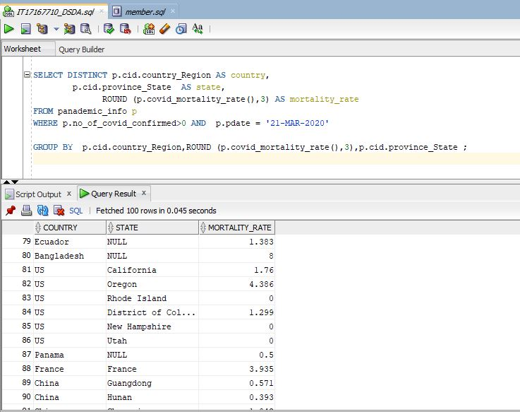

**SELECT** p**.**cid**.**country_Region **AS** country **,**

p**.**cid**.**province_State **AS** **State** **,**

**SUM(**p**.**no_of_covid_Recovered **)AS** total_Recovered**,**

**SUM(**p**.**no_of_covid_deaths**)AS** total_DEATH**,**

**sum(**p**.**no_of_covid_confirmed**)AS** total_confirmed

**FROM**

panademic_info p

**WHERE**

p**.**pdate **=** '21-MAR-2020' **AND**

p**.**no_of_covid_confirmed **IN**

**(SELECT** **sum(**p**.**no_of_covid_confirmed**)**

**from** panademic_info p

**group** **by** p**.**no_of_covid_confirmed

**HAVING** **sum(**p**.**no_of_covid_confirmed**)>**1000**)**

**GROUP** **BY** p**.**cid**.**country_Region**,**p**.**cid**.**province_State**,**p**.**no_of_covid_confirmed

**HAVING** **SUM(**p**.**no_of_covid_Recovered**)**

**<** **SUM(**p**.**no_of_covid_deaths**)**

**/**

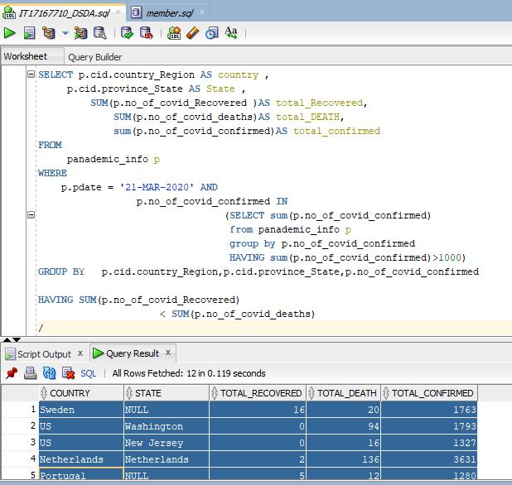

**SELECT**

p**.**cid**.**country_Region **AS** country**,**

p**.**cid**.**province_State **AS** **state,**

**SUM(**p**.**no_of_covid_confirmed**)AS** total_confirmed**,**

**SUM(**p**.**no_of_covid_Recovered**)** **AS** total_Recovered**,**

**ROUND(** p**.**covid_recoverRate**(),**3**)AS** Recovery_Rate**,**

**SUM(**p**.**no_of_covid_deaths**)** **AS** total_DEATH**,**

**ROUND(** p**.**covid_mortality_rate**(),**3**)** **AS** mortality_rate

**FROM**

panademic_info p

**WHERE**

p**.**pdate **=** '21-MAR-2020' **AND** p**.**no_of_covid_confirmed**>**0

**GROUP** **BY**

p**.**cid**.**country_Region**,ROUND(** p**.**covid_recoverRate**(),**3**),ROUND(** p**.**covid_mortality_rate**(),**3**),**p**.**cid**.**province_State

**/**

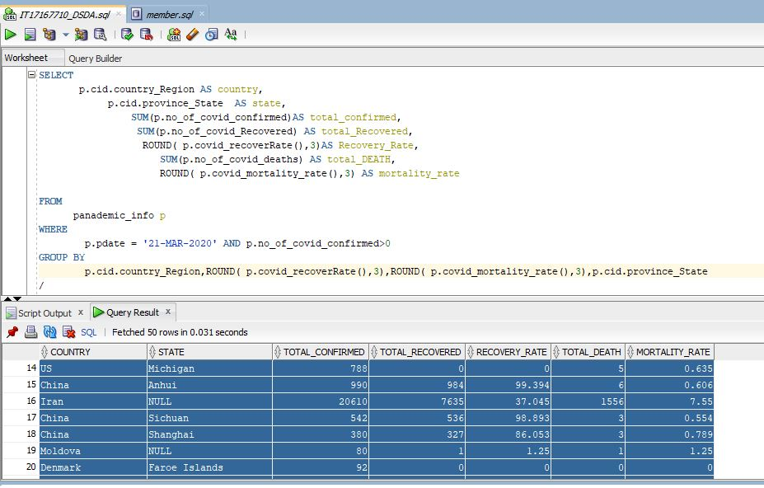

**SELECT**

p**.**cid**.**province_State **AS** **State** **,**

**SUM(**p**.**no_of_covid_deaths**)AS** total_DEATH**,**

**SUM(**p**.**no_of_covid_Recovered **)AS** total_Recovered**,**

**sum(**p**.**no_of_covid_confirmed**)AS** total_confirmed

**FROM** panademic_info p

**WHERE** p**.**pdate **=** '21-MAR-2020' **AND** p**.**cid**.**country_Region **=**'US'

**GROUP** **BY**

p**.**cid**.**province_State**,**p**.**no_of_covid_confirmed

**HAVING** **SUM(**p**.**no_of_covid_Recovered**)**

**<** **SUM(**p**.**no_of_covid_deaths**)**

**/**

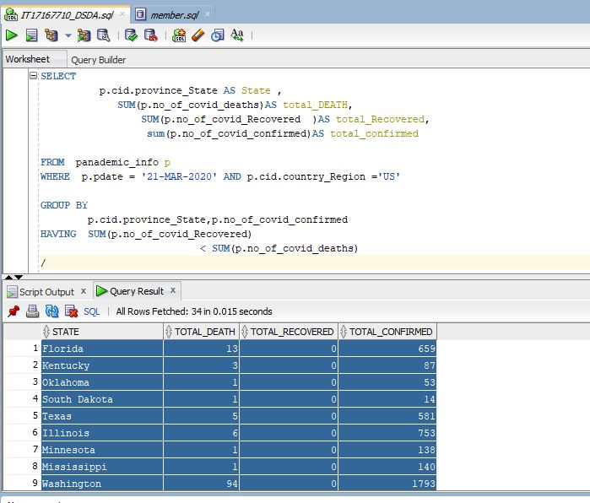

**SELECT**

p**.**cid**.**country_Region **AS** country**,**

**SUM(**p**.**no_of_covid_confirmed**)** **AS** confirmed_patients**,**

**SUM(**p**.**no_of_covid_Recovered**)** **AS** Recovered_patients**,**

**SUM(**p**.**no_of_covid_deaths**)AS** died_patients**,**

p**.**numberOf_non_recover**()** **AS** Not_recoverd_patients**,**

p**.**cid**.**latitude **AS** latitude**,**

p**.**cid**.**longtude **as** longtude

**FROM** panademic_info p

**WHERE** p**.**no_of_covid_confirmed**>**0 **AND** p**.**pdate **=** '21-MAR-2020'

**GROUP** **BY**

p**.**cid**.**country_Region**,** p**.**cid**.**latitude**,** p**.**cid**.**longtude**,** p**.**numberOf_non_recover**()**

**HAVING** p**.**numberOf_non_recover**()>**10000

**/**

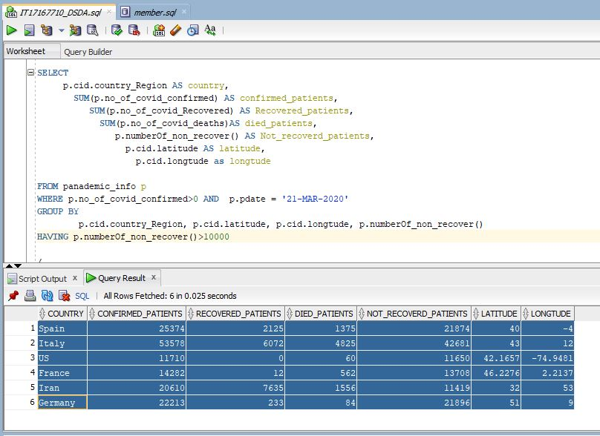

**SELECT**

p**.**cid**.**country_Region **AS** country**,**

**SUM(**p**.**no_of_covid_confirmed**)** **AS** confirmed_patients**,**

**SUM(**p**.**no_of_covid_Recovered**)** **AS** Recovered_patients**,**

**SUM(**p**.**no_of_covid_deaths**)AS** died_patients**,**

**SUM(**p**.**numberOf_non_recover**())AS** not_Recovered_patients

**FROM** panademic_info p

**WHERE**

p**.**no_of_covid_confirmed**>**0 **AND** p**.**pdate **=** '21-MAR-2020'

**GROUP** **BY** p**.**cid**.**country_Region

**HAVING** **(SUM(**p**.**numberOf_non_recover**()))<**

**SUM(**p**.**no_of_covid_Recovered**)**

**/**

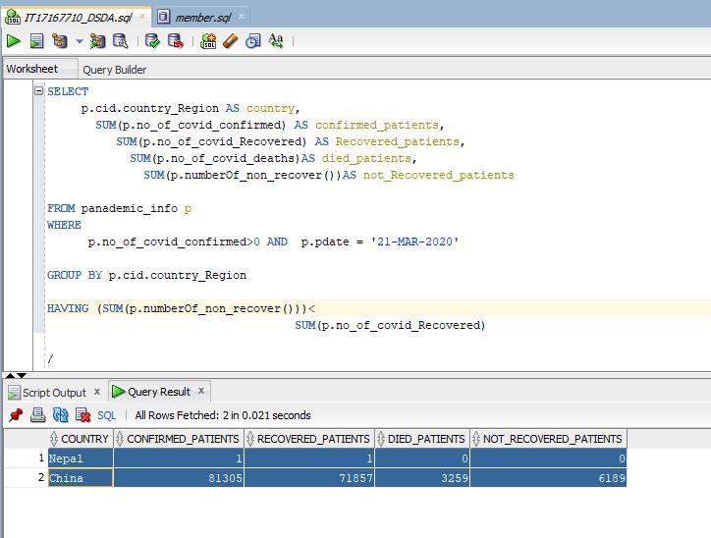

**SELECT** p**.**cid**.**country_Region **AS** country**,**

**SUM(**p**.**no_of_covid_confirmed**)** **AS** confirmed_patients**,**

**ROUND** **(** **AVG(**p**.**no_of_covid_Recovered**),**2**)** **AS** Avarage_Recovered_patients**,**

**ROUND** **(** **AVG(**p**.**no_of_covid_deaths**),**2**)** **AS** Avarage_died_patients**,**

**ROUND** **(** **AVG(**p**.**numberOf_non_recover**()),**2**)AS** Avarage_not_Recovered_patients

**FROM** panademic_info p

**WHERE** p**.**no_of_covid_confirmed**>**0 **AND** p**.**pdate **=** '21-MAR-2020'

**GROUP** **BY** p**.**cid**.**country_Region

**HAVING** **SUM(**p**.**no_of_covid_Recovered**)** **<** **SUM(**p**.**no_of_covid_deaths**);**

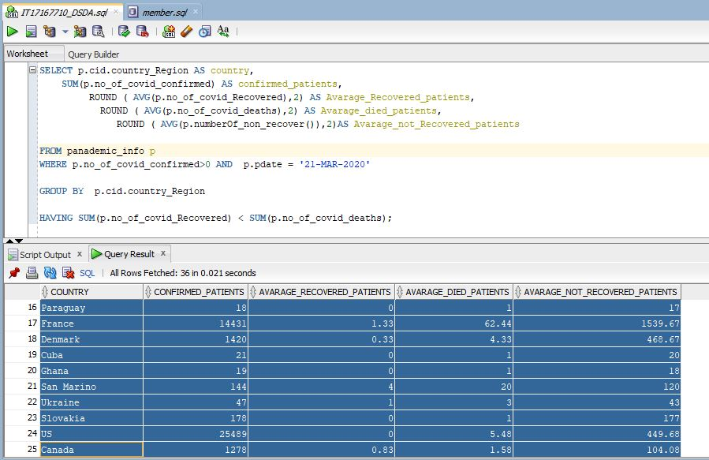

**SELECT** p**.**cid**.**country_Region **AS** country**,**

**ROUND** **(**p**.**covid_recoverRate**(),**3**)** **AS** Recovered_patients_rate**,**

**ROUND** **(** p**.**covid_mortality_rate**(),**3**)AS** rate_mortality_rate**,**

**ROUND** **(**p**.**non_recover_rate**(),**3**)** **AS** not_Recovered_patients_rate

**FROM** panademic_info p

**WHERE** p**.**no_of_covid_confirmed**>**0 **AND** p**.**pdate **=** '21-MAR-2020'

**GROUP** **BY** p**.**cid**.**country_Region**,** **ROUND** **(**p**.**covid_recoverRate**(),**3**),** **ROUND** **(** p**.**covid_mortality_rate**(),**3**),** **ROUND** **(**p**.**non_recover_rate**(),**3**);**

